**Spring boot**

**Spring core**

**Spring context**

**Spring mvc**

**Spring rest**

**Spring security**

**Spring orm**

**Spring dao**

**Etc**

**Spring boot is type of spring module which help to develop spring framework with less configuration.**

**Spring boot = all spring modules – no xml file (beans.xml or dispatcher-servlet.xml file) + few annotation + inbuild web server ie tomcat or jetty server.**

**Spring boot itself is standalone project mean core java project. Which help to create any type of projects. It is bootstrap for spring framework.**

**CSS Vs Bootstrap**

**Spring boot components**

1. **Spring boot starter : Spring boot starter provided only one dependencies depending upon type of project. Which help to add all required jar files.**

**Web starter : which provided all required jar file including inbuild tomcat server.**

**Jdbc starter : which provided all required jar file which help to connect database.**

**Jpa starter : which provided all jar file which help to achieve orm features.**

1. **Spring boot auto configuration : depending upon type of starter which we added in spring application it provided DI for those resources.**

**Example : in spring boot web starter we no need to configure external tomcat server, no need to configure dispatcher-servlet in web.xml file.**

**No xml file. Few configuration using annotation.**

**Spring boot provided pre defined annotation ie**

**@SpringBootApplication = @Configuration + @ComponentScan + @AutoConfiguration.**

**If we need any other configuration like database or security we need to add in properties or yml file.**

**In spring boot we use application.properties or application.yml file.**

**Inside this file we need to provide all configuration details depending upon the starter.**

**YAML (Yet Another Markup language). Provide information in key=value pairs.**

**Spring boot with**

**Maven built tool if we use maven tool. Then pom.xml file present. This file is part of maven not a part of spring boot.**

**Gradle built tool : no xml file we use build file.**

**Creating Simple Spring boot project with web starter**

1. **Create maven project**
2. **Add properties tag to change the version of java and add one starter ie web starter.**
3. **Now we need to create normal java class with main method.**
4. **On main class we need to use @SpringBootApplication annotation.**
5. **Spring boot provided pre defined class ie SpringApplication which contains run static method to start the spring boot application.**
6. **By default spring boot internal tomcat server run on default port number 8080.**

Open the browser

<http://localhost:8080>

Spring boot with View

1. View can be JSP

We need to starter JSP dependencies if we need view as JSP

Inside src/main folder create the folder with name as webapp

Inside this folder we can create more than one jsp pages.

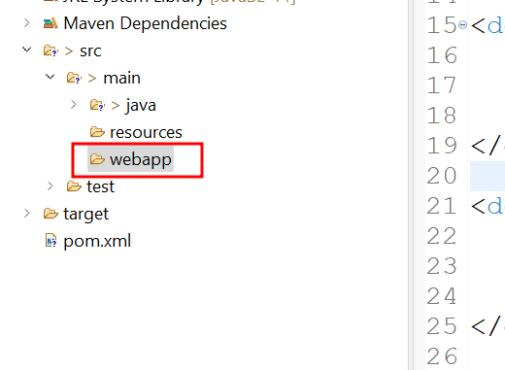

Now we need to create the application.properties file and provide the view resolver details inside this file. Application.properties file must be insider resource folder.

1. View can be Thymeleaf

We need View as Thymeleaft then we need to add Thymeleaf starter.